# Intel ® Ethernet Adapters

# Quick Install Guide

**M:\中性CD\Intel Network Driver\ Drivers  18.3\PRO100\DOCS\SERVER\ce.gif**

**All brand names and trademarks are properties of their**

**Respective owners.**

Thank you for choosing to use INTEL series network products, these products can provide you with high performance and high reliability of network services, also much INTEL's adapter support unique features, such as PXE,WOL, Teaming, VMs, UEFI, Flow control, FCoE and so on, these features can help you improve computer network utilization, network bandwidth, and network control ability, the card is widely used in personal computers, servers and industrial areas.

***Hardware installation***

***1.Select the Correct Slot***

One open PCI-Express slot,x1,x4,x8 or x16,depending on your adapter.

NOTE: Some systems have physical x8 PCI Express slot that actually only support lower speeds. Please check your system manual to identify the slot.

***2.Insert the Adapter into the Computer***

1. If your computer supports PCI Hot Plug,see your computer documentation for special installation instructions.
2. Turn off and unplug your computer. Then remove the cover.
3. Remove the cover bracket from an available slot. If you have configuration problems, see your computer’s documentation to determine if the PCI-Express or PCI slots are bus master-enabled.
4. Firmly insert the adapter into the selected slot. Push down to ensure the adapter is firmly seated, if you install the adapter in a PCI-Express or PCI slot, make sure the exposed end of the connector does not touch any part of the motherboard. Secure the bracket to the chassis.

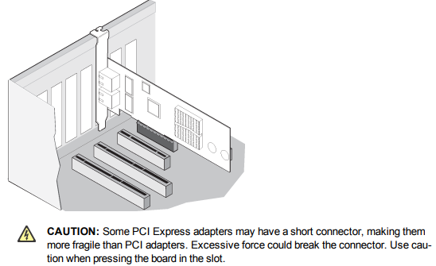Note: If you need to install the adapter in a low profile PCI-Express or PCI chassis, first replace the adapter standard with the supplied low profile bracket. To remove existing bracket, unscrew the two screws an shown at right and then pull bracket off. Reverse the process to attach the low profile bracket.

1. Replace the computer cover and plug in the power cord.

***Connect the Network Cables***

1. ***Connect copper cables:*** Connect the RJ-45 network cable as shown

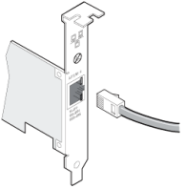 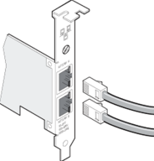 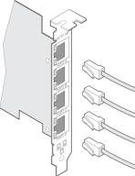

* For 10GBASE-T on Category 6,Category6a,or Category 7wiring,twisted 4-pair copper:

|  |  |  |  |
| --- | --- | --- | --- |
| Twist pair | Category 6 | Category 6a | Category 7 |
| Length | 55 meters | 100 meters | 100 meters |

* For 1000BASE-T or 100BASE-TX use Category 5 or Category5e wiring. twisted 4-pair copper
* For 10BASE-T use Category 3 or 5 wiring, with twisted 2-pair copper

1. ***Connect the fiber models***

* For fiber adapter, remove and save the fiber optic connector cover. Insert a matching fiber optic connector into the ports on the adapter.

Note: For LC adapters, converter patch cables are available to allow plugging into an SC type connector.

* The SX type adapters must use Multi-mode compatible cabling and the LX type adapter must use Single-mode compatible cabling. Cabling and adapter types cannot be mixed.

Note: the LX adapter has LX stamped on the bracket to identify it. See the User’s Guide on the CD for More information on cable types.

|  |  |  |  |
| --- | --- | --- | --- |
| **Fiber cable type:** | **MM 62.5u** | **MM 50u** | **SM 9.0u** |
| **100BASE-FX TYPE(850nm)** | **N/A** | **N/A** | **20KM** |
| **100BASE-FX TYPE(1310nm)** | **2kM** | **2kM** | **N/A** |
| **1000BASE-SX TYPE(850nm)** | **275M** | **550M** | **N/A** |
| **1000BASE-SX TYPE(1310nm)** | **N/A** | **N/A** | **10KM** |
| **10GBASE-SR TYPE(850nm)** | **N/A** | **300M** | **N/A** |
| **10GBASE-LR TYPE(1310nm)** | **N/A** | **N/A** | **10KM** |
| **25GBASE-SR/LC TYPE(850nm)** | **33M MAX** | **300M MAX** | **N/A** |
| **40GBASE-SR4 TYPE(850nm)** | **N/A** | **100M MAX** | **N/A** |

1. ***For SFP,SFP+,QSFP+ fiber models, more of models used LC port, please refer to above table***

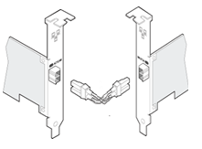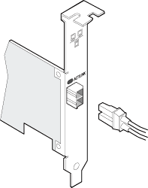



Optical fiber connection diagramSingle-port fiber adapter with LC connector

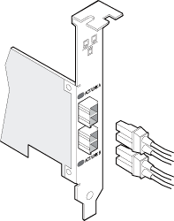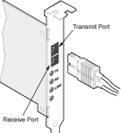

Dual-port fiber adapter with LC connector single-port fiber adapter with sc connector

***Install Drivers and software***

**System Requirements :**FreeBSD, Linux , VMWare ESXi, Win7/ Win-server2012/ Win-server2008/ Win8/Win8.1/Win-server2016/win10 32 or 64bit

**NOTE: Microsoft Windows 32-bit operating systems are only supported on Intel 1GbE Ethernet Adapters and slower devices. All adapter supports 32-bit version of Linux and FreeBSD**

**Windows Operating Systems**

You must have administrative rights to the operating system to install the drivers.

1. insert the CD driver bound with Intel network driver into your CD-ROM drive(also you can download the latest drivers from [support website](https://downloadcenter.intel.com/product/36773/Ethernet-Products)):
2. if the Found New Hardware Wizard screen is displayed, click **Cancel**
3. start the autorun located in the software package, the autorun may automatically start after you have extracted files.
4. Click **install Drivers and Software**
5. Follow the instructions in the install wizard to finish it

**Installing Linux Drivers from Source Code**

1. Download and expand the base driver tar file.
2. Compile the driver module
3. Install the module using the modprobe command
4. Assign an IP address using the ifconfig command

***MAC Address information***

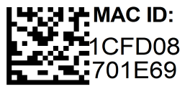 (barcode TYPE 1)



(Barcode TYPE 2)

All adapters have a MAC address label attached to them, and each address is unique. If it is a multi-port adapter card, the first port address is printed on the barcode, the address of the next port can be obtained by add one 1 (hexadecimal)according to the address value of the barcode label.

***Package content***

1.Intel Ethernet adapter. 3.user’s manual  
2.driver CD 4.Low profile bracket

***Support***

More information and settings, please refer to the Intel Adapter User Guides or you can contact us.